# 

**Application for Research at Pierce Cedar Creek Institute**

**Name: Email:**

**Institution:**

**Address:**

**Phone: Cell Phone:**

**Title of Research:**

**Expected duration of project:**

**Do you require any special permits for your research?**

**If so, please attach copies of the permits to the application.**

**Please provide a brief description of research and methods (include sampling method and equipment, approximate number of samples to be taken, and describe any disturbance you might do on research sites):**

**What is the approximate size and location of the research area? Use the map below to highlight the area(s) that will be used for research.**

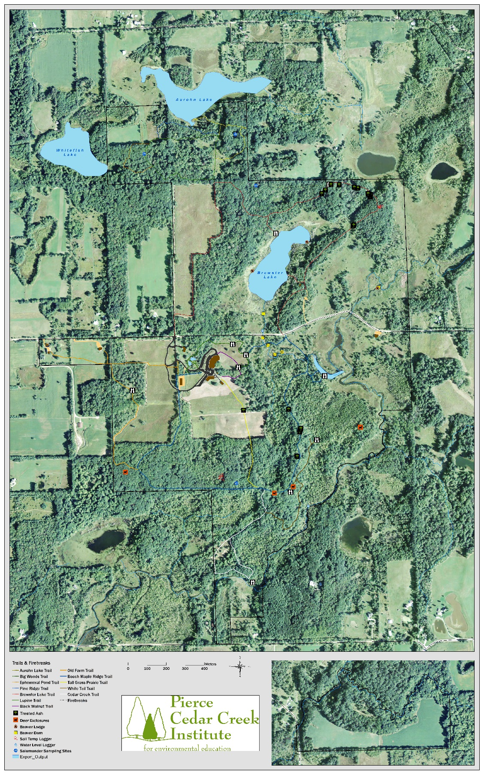

***Pierce Cedar Creek Institute Research Policies***

# Alcohol, Tobacco, and Drugs:

* Pierce Cedar Creek Institute buildings and grounds are alcohol and drug free. Researchers are required to comply with the Institute’s policies. Smoking is extremely restricted and only allowed outside, next to the Housing Units and in Researcher’s vehicle.

# Emergencies:

* Barry County has enhanced 911 for fire, health, and police emergencies. Any 911 call must be reported immediately to the Facility Manager at 616-862-3115, or any Institute staff.
* On phones in the Research Lab, Visitor Center, or Education Building, dial “9” to get an outside line, and then dial 911.

**Firearms/Hunting**

* Firearms are not allowed on the property except by special permission**.** Researchers should be aware that the Institute has a deer management program and allows hunting by special permission. The trails are closed from November 15 until November 30. Trails north of Cloverdale are closed through January 1

# Office Space/Research Lab:

* Researcher may request access to the Research Lab for research purposes.
* Contact Ellen Holste at 269-721-4170 to arrange usage.
* Wireless Internet service is available in the Visitor Center, Research Lab and Education Building.

# Personal Property:

* The Institute shall not be responsible for any loss or damage to personal property belonging to Researcher, staff, or guests. Each researcher is responsible for his or her personal security and for the security of his or her possessions.

# Researcher shall be held responsible for lost, stolen, or damaged equipment and supplies belonging to the Institute. Please report any loss or damage promptly to the Field Station Manager.

# Research Projects:

* No sampling will be performed on site at the Institute that is not clearly defined in the research application.
* Any alterations to Institute property required for research that are not clearly explained in the application must be approved in writing prior to execution.
* Only biodegradable flags and marking tape may be used on Institute property. Upon completion of research, Researcher shall remove all flags, marking tape, and any other materials used on the property.
* Researchers are responsible for obtaining any and all appropriate state or federal permits for their research. Copies of the permits must be attached to the application.
* Researchers will understand that there is a potential for dangerous and harmful situations due to the organisms and environment found at the Institute. The Researcher shall use caution while performing field work.
* Researchers shall use proper personal safety equipment when handling dangerous tools or chemicals.
* No equipment or disturbances may be left in the field. If the equipment or disturbance is part of a continuing or new research project, the researcher must fill out a new research application.

# Reporting and Publications:

* Researchers will file an annual report to the Research and Community Engagement Manager that includes: a brief update of the project, a summary of the results for the year, and a list of data generated. The report will be due at a time agreed upon by the researcher and the Institute staff.
* All publications arising from work done on site or with samples from the Institute will acknowledge support from the Institute.
* Researcher will provide the Institute a copy of any publications of the research conducted on site to be held in the Institute’s library. Some of the Researcher information may be placed on the Institute’s website. The Institute will give Researcher credit when their material is used.

# Termination:

* Either party may terminate this agreement by giving the other party written notice of the termination.

# Vehicles:

* Personal vehicles are not allowed on the trails at any time. If research equipment must be transported to sites on the property not accessible by roads, Researcher may request staff assistance with the use of Institute vehicles. Researchers may park in any of the parking lots by the Visitor Center, Education Building, Research Lab, and also in the parking area near Batt’s Cottage.

# Indemnification

During my work at Pierce Cedar Creek Institute, I understand that some activities may be strenuous and adverse weather conditions may occur. Nevertheless, I assume the risks involved. I shall not hold the Institute liable for any damages or injury to my personal belongings, or myself occurring on the premises, or any part thereof. I agree to hold the Institute harmless from any claims and/or damages.

I have read and agree to the stipulations contained in this Application:

**____________________ ___________________________**

**Researcher Researcher**

**_________________ ___________________________**

**Printed Name Printed Name**

**Date:___________ Date:__________________**

**___________________________________________**

**Educational Institution**

Application must be returned at least one week prior to beginning of Researcher project and is subject to review by Institute staff. No work shall begin prior to approval by the Institute.

Note: Major projects may require a Memorandum of Agreement prior to the start of work at the Institute.

### Please return this signed agreement to: Ellen Holste

Research and Community Engagement Manager

Pierce Cedar Creek Institute

701 W. Cloverdale Road

Hastings, MI 49058

[eholste@cedarcreekinstitute.org](mailto:eholste@cedarcreekinstitute.org)

269-721-4170