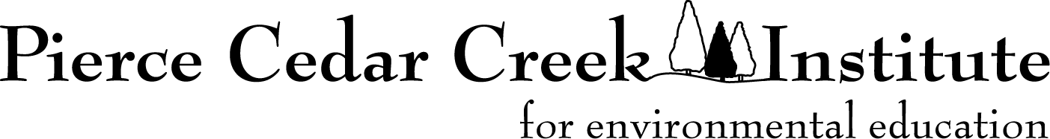

Creative Fellowship Mentor Application for 2024

General Information

- Purpose:

The purpose of the Creative Arts Fellowships is to nurture the creative development of promising student artists and writers interested in producing works inspired and influenced by the natural world. The Institute believes the opportunity to combine field experiences, with reflection and immersion in a creative community, through a focused project will result in meaningful and possibly life-changing learning experiences for emerging student artists and writers. The student projects may be individual or collaborative with other students or mentors. The Institute believes diverse perspectives and backgrounds will help the entire community grow and develop.

We recognize that students will best reach their potential by having an experienced mentor work with them during the program. Mentors will have diverse experience in creative work and mentoring students. During the program, mentors will establish regular, individual and collective meetings with student fellows to discuss and provide feedback on their work. They will work with fellows to develop a personal project timeline and help fellows meet their project goals. Mentors will also design and facilitate on-site learning professional development activities with student fellows and participate in activities with Institute staff, researchers, and other writers and artists.

The fellowships will include a residency period for students from June 17 through July 19, 2024. A Final Report Meeting where student fellows share their work will be held on August 7, 2024. Residency is not required for faculty mentors; however, housing is available. We expect mentors to be on-site a minimum of two to three days per week. Mentors are welcome to use the balance of time working on their own projects.

Eight to ten fellowships divided evenly between visual arts and creative writing will be awarded for 2024. We will have two mentors, one focused on creative writing and the other on the visual arts.

- Eligibility:

The mentor positions for the Creative Arts Fellowships program are available to faculty attending one of the member colleges or universities of the Pierce Cedar Creek Consortium (see list at https://cedarcreekinstitute.org/research.html).

- Mentor Stipend:

Mentors will receive a $4,000 stipend. Stipends will be paid in two installments, the first at the beginning of the program and the second after the final program is complete.

Housing will be available at the Institute, along with breakfast and lunch Monday through Friday when onsite. Mentors will need to provide for their own meals outside of the provided meals if they stay on-site.

The announcement of the mentors will be made by March 31, 2024.

- Responsibilities and Reporting:

The following is required for all mentors:
- Participate in an orientation meeting at the Institute on April 13, 2024.
- Hold virtual meetings with students before the program to establish cohort communication and help prepare students for the fellowship experience.
- Participate in all aspects of the summer program, including scheduling regular meetings and activities with fellows.
- Participate in a summer report program on August 7, 2024.
- Help review work summaries of the fellows.
- Complete an evaluation of the program.

Application and Guidelines

Please send a cover letter and resume/short CV/biosketch as a .docx or .pdf file to Matthew Dykstra (mdykstra@cedarcreekinstitute.org) by February 29, 2024.

Questions are welcome and can be directed to Matthew Dykstra - Field Station Manager at mdykstra@cedarcreekinstitute.org or 269-721-4473

Creative Fellowships Application

Application - Cover Sheet

Deadline for Application: February 29, 2024

College or University:

Faculty Member

Name:
Local/Campus Address:
Permanent Address:
Phone: E-mail:
Driver’s License State and Number (for background check)
Are you a US Citizen?

Professional Reference
Name: Department:
Address:
Phone: E-mail:

Professional Reference
Name: Department:
Address:
Phone: E-mail:

Signatures - By signing below, mentors confirm that if selected, they will follow the requirements listed above, including Institute policies and procedures, and commit sufficient time and effort to ensure effective mentorship of the student fellows.

________________________________ ________
Signature Date

701 W. Cloverdale Road, Hastings, MI 49058 | 269-721-4190 | www.cedarcreekinstitute.org

