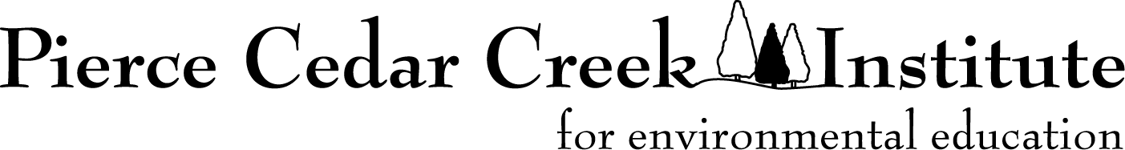

Creative Fellowship Mentor Application for 2023

General Information

- Purpose:

The purpose of the Creative Arts Fellowships is to nurture the creative development of promising student artists and writers interested in producing works inspired and influenced by the natural world. The Institute believes the opportunity to combine field experiences, with reflection and immersion in a creative community, through a focused project will result in meaningful and possibly life-changing learning experiences for emerging student artists and writers. Projects may be individual or collaborative with other students or mentors. The Institute believes diverse perspectives and backgrounds will help the entire community grow and develop.

We recognize that students will best reach their potential by having an experienced mentor work with them during the program. Mentors will have diverse experience in creative work and mentoring students. During the program, mentors will establish regular, individual and collective meetings with student fellows to discuss and provide feedback on their work. Mentors will also design and facilitate on-site learning activities with student fellows and participate in activities with Institute staff, researchers, and other writers and artists.

The fellowships will include a residency period for students from June 26 through July 28, 2023. A Final Report Meeting where student fellows share their work will be held on August 3, 2023. Residency is not required for faculty mentors; however, housing will be available. We expect mentors to be on-site two to three days per week. Mentors are welcome to use the balance of time working on their own projects.

Approximately eight fellowships will be awarded for 2023 with two mentors, one focused on creative writing and the other on the arts.

- Eligibility:

The mentor positions for the Creative Arts Fellowships program are available to faculty attending one of the member colleges or universities of the Pierce Cedar Creek Consortium (see list at https://cedarcreekinstitute.org/research.html).

- Mentor Stipend:

Mentors will receive a $4,000 stipend. Stipends will be paid in two installments, the first at the beginning of the program and the second after the final program is complete.

Housing will be available at the Institute, along with breakfast and lunch Monday through Friday when onsite. Mentors will need to provide for their dinners when on-site.

The announcement of the mentors will be made by March 15, 2023.

- Responsibilities and Reporting:

The following is required for all mentors:
- Participate in a virtual orientation meeting on May 17, 2023.
- Hold virtual meetings with students before the program to establish cohort communication and help prepare students for the fellowship experience.
- Participate in all aspects of the summer program, including scheduling regular meetings and activities with fellows.
- Participate in a summer report program on August 3, 2023.
- Help review work summaries of the fellows.
- Complete an evaluation of the program.

Application and Guidelines

Please send a cover letter and resume/short CV/biosketch as a .docx or .pdf file to Matthew Dykstra (mdykstra@cedarcreekinstitute.org) by March 2, 2023.

Any questions regarding the fellowships can be directed to Matthew Dykstra - Field Station Manager, mdykstra@cedarcreekinstitute.org or 269-721-4473

Creative Fellowships Application

Application - Cover Sheet

Deadline for Application: March 2, 2023

College or University:

Faculty Member

Name:
Local/Campus Address:
Permanent Address:
Phone: E-mail:
Driver’s License State and Number (for background check)
Are you a US Citizen?

Professional Reference
Name: Department:
Address:
Phone: E-mail:

Professional Reference
Name: Department:
Address:
Phone: E-mail:

Signatures - By signing below, mentors confirm that if funded, they will follow the requirements of the fellowship, including Institute policies and procedures, and commit sufficient time and effort to ensure completion of the proposed work.

________________________________ ________
Signature Date

701 W. Cloverdale Road, Hastings, MI 49058 | 269-721-4190 | www.cedarcreekinstitute.org

